**Program 5 (Equivalence class testing for Commission program)**

**/* Design. Develop, code and run the program in nay suitable language to solve the commission problem. Analyze it from the perspective of boundary value, derive test cases, execute these test cases and discuss the test results */**

**/* Assumption price for lock=45.0, stock=30.0 and barrels=25.0 production limit could sell in month 70 locks,80 stocks and 90 barrels commission on sales = 10 % <= 1000 and 15 % on 1000 to 1800 and 20 % on above 1800*/**

PROGRAM:

#include<stdio.h>

int main()

{

// Anirudh Krishnaprasad 1CR18IS017

int locks, stocks, barrels, tlocks, tstocks, tbarrels;

float lprice, sprice, bprice, sales, comm;

int c1,c2,c3,temp;

lprice=45.0;

sprice=30.0;

bprice=25.0;

tlocks=0;

tstocks=0;

tbarrels=0;

printf("\nEnter the number of locks and to exit the loop enter -1 for locks\n");

scanf("%d",&locks);

while(locks!=-1)

{

c1=(locks<=0||locks>70);

printf("Enter the number of stocks and barrels\n");

scanf("%d%d",&stocks,&barrels);

c2=(stocks<=0||stocks>80);

c3=(barrels<=0||barrels>90);

if(c1)

printf("Value of locks not in the range 1..70 ");

else

{

temp=tlocks+locks;

if(temp>70)

printf("New total locks =%d not in the range 1..70 so old ",temp);

else

tlocks=temp;

}

printf("Total locks = %d\n",tlocks);

if(c2)

printf("Value of stocks not in the range 1..80 ");

else

{

temp=tstocks+stocks;

if(temp>80)

printf("New total stocks =%d not in the range 1..80 so old ",temp);

else

tstocks=temp;

}

printf("Total stocks=%d\n",tstocks);

if(c3)

printf("Value of barrels not in the range 1..90 ");

else

{

temp=tbarrels+barrels;

if(temp>90)

printf("new total barrels =%d not in the range 1..90 so old ",temp);

else

tbarrels=temp;

}

printf("Total barrel = %d",tbarrels);

printf("\nEnter the number of locks and to exit the loop enter -1 for locks\n");

scanf("%d",&locks);

}

printf("\nTotal locks = %d\nTotal stocks = %d\nTotal barrels = %d\n",tlocks,tstocks,tbarrels);

sales = lprice*tlocks+sprice*tstocks+bprice*tbarrels;

printf("\nThe total sales = %f\n",sales);

if(sales > 0)

{

if(sales > 1800.0)

{

comm=0.10*1000.0;

comm=comm+0.15*800;

comm=comm+0.20*(sales-1800.0);

}

else if(sales > 1000)

{

comm =0.10*1000;

comm=comm+0.15*(sales-1000);

}

else

comm=0.10*sales;

printf("The commission is = %f\n",comm);

}

else

printf("There is no sales\n");

return 0;

}

**Screenshot of the program:**

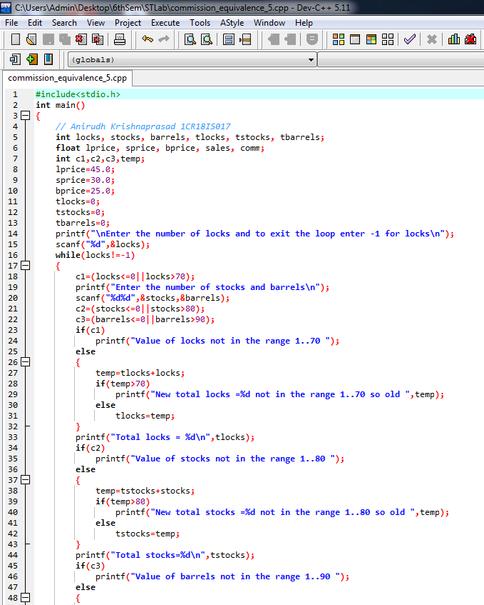

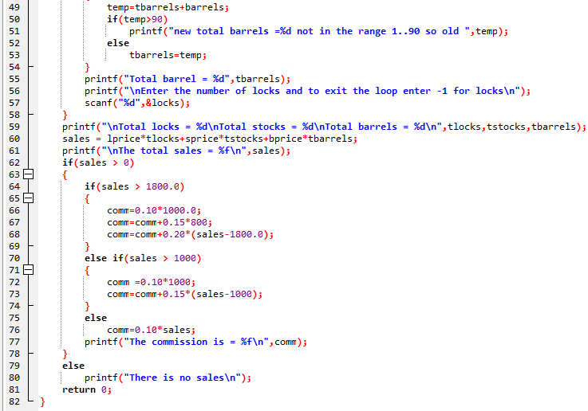

**Screenshots:**

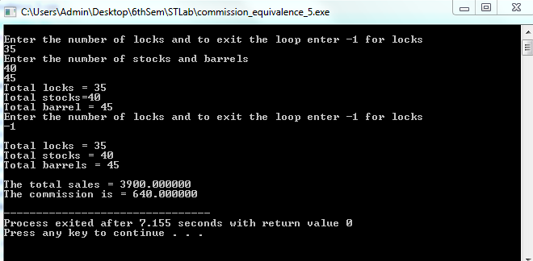

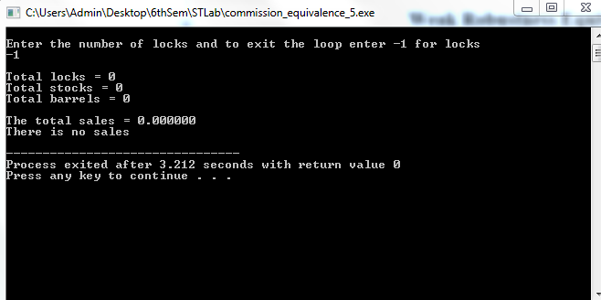

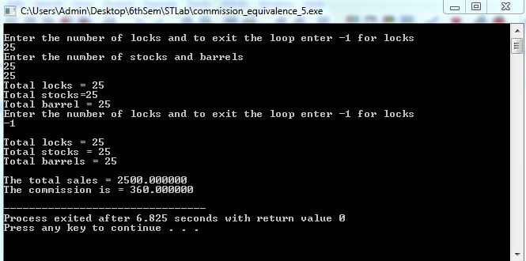

**Test Cases:**

Commission Problem Output Equivalence Class Testing

**( Weak & Strong Normal Equivalence Class )**

|  |  |  |  |  |  |  |  |  |  |  |
| --- | --- | --- | --- | --- | --- | --- | --- | --- | --- | --- |
| Case  ID: | Description | Input Data | | | Expected Output | | Actual Output | | Status | Comments |
| Locks | Stocks | Barrels | Sales | Commi-  ssions | Sales | Commi-  ssions |
| 1 | Enter the value within the range for locks, stocks and barrels | 35 | 40 | 45 | 3900 | 640 | 3900 | 640 | Done | No issue |

Weak Robustness Equivalence Class

|  |  |  |  |  |  |  |  |  |
| --- | --- | --- | --- | --- | --- | --- | --- | --- |
| Case  ID | Description | Input data | | | Output Expected | Actual Output | Status | Comment |
| Locks | Stocks | Barrels |
| WR1 | Enter the value locks = -1 | -1 | 40 | 45 | Terminates the input loop and proceed  to calculate sales and commission ( if  Sales > 0) | There is no sales | working | No issue |
| WR2 | Enter the value less than -1 or equal to  zero for locks and other valid inputs | 0 | 40 | 45 | Value of Locks not in the range 1..70 | Value of Locks not in the range 1..70 | Working | No issue |
| WR3 | Enter the value greater than 70 for  locks and other valid inputs | 71 | 40 | 45 | Value of Locks not in the range 1..70 | Value of Locks not in the range 1..70 | working | No issue |
| WR4 | Enter the value less than or equal than  0 for stocks and other valid inputs | 35 | 0 | 45 | Value of stocks not in the range 1..80 | Value of stocks not in the range 1..80 | working | No issue |
| WR5 | Enter the value greater than 80 for  stocks and other valid inputs | 35 | 81 | 45 | Value of stocks not in the range 1..80 | Value of stocks not in the range 1..80 | working | No issue |
| WR6 | Enter the value less than or equal 0 for  barrels and other valid inputs | 35 | 40 | 0 | Value of stocks not in the range 1..90 | Value of stocks not in the range 1..90 | working | No issue |
| WR7 | Enter the value greater than 90 for  barrels and other valid inputs | 35 | 40 | 91 | Value of stocks not in the range 1..90 | Value of stocks not in the range 1..90 | working | No issue |

Strong Robustness equivalence Class

|  |  |  |  |  |  |  |  |  |
| --- | --- | --- | --- | --- | --- | --- | --- | --- |
| Case  ID | Description | Input data | | | Output Expected | Actual Output | Status | Comment |
| Locks | Stocks | Barrels |
| SR1 | Enter the value less than -1 for locks  and other valid inputs | -2 | 40 | 45 | Value of Locks not in the range 1..70 | Value of Locks not in the range 1..70 | working | No issue |
| SR2 | Enter the value less than or equal than  0 for stocks and other valid inputs | 35 | -1 | 45 | Value of stocks not in the range 1..80 | Value of stocks not in the range 1..80 | working | No issue |
| SR3 | Enter the value less than or equal 0 for  barrels and other valid inputs | 35 | 40 | -2 | Value of Locks not in the range 1..70 | Value of Locks not in the range 1..70 | working | No issue |
| SR4 | Enter the locks and stocks less than or  equal to 0 and other valid inputs | -2 | -1 | 45 | Value of Locks not in the range 1..70 | Value of Locks not in the range 1..70 | working | No issue |
| Value of stocks not in the range 1..80 | Value of stocks not in the range 1..80 |
| SR5 | Enter the locks and barrel less than or  equal to 0 and other valid inputs | -2 | 40 | -1 | Value of Locks not in the range 1..70 | Value of Locks not in the range 1..70 | working | No issue |
| Value of Locks not in the range 1..90 | Value of Locks not in the range 1..90 |
| SR6 | Enter the stocks and barrel less than or  equal to 0 and other valid inputs | 35 | -1 | -1 | Value of stocks not in the range 1..80 | Value of stocks not in the range 1..80 | working | No issue |
| Value of Locks not in the range 1..90 | Value of Locks not in the range 1..90 |
| SR7 | Enter the stocks and barrel less than or  equal to 0 and other valid inputs | -2 | -2 | -2 | Value of Locks not in the range 1..70 | Value of Locks not in the range 1..70 | working | No issue |
| Value of stocks not in the range 1..80 | Value of stocks not in the range 1..80 |
| Value of Barrels not in the range 1..90 | Value of Barrels not in the range 1..90 |

**Some addition equivalence Boundary checking**

|  |  |  |  |  |  |  |  |  |  |  |
| --- | --- | --- | --- | --- | --- | --- | --- | --- | --- | --- |
| Case  ID: | Description | Input Data | | | Expected Output | | Actual Output | | Status | Comments |
| Locks | Stocks | Barrels | Sales | Commi-  ssions | Sales | Commi-  ssions |
| OR1 | Enter the value for lock, stocks and  barrels where 0 < Sales < 1000 | 5 | 5 | 5 | 500 | 50 | 500 | 50 | working | No issue |
| OR2 | Enter the value for lock, stocks and  barrels where 1000 < Sales < 1800 | 15 | 15 | 15 | 1500 | 175 | 1500 | 175 | working | No issue |
| OR3 | Enter the value for lock, stocks and  barrels where Sales < 1800 | 25 | 25 | 25 | 2500 | 360 | 2500 | 360 | working | No issue |